VOIP lab experiment#5
Installing IP Phone

Installation and Repair of Telecommunications Equipment

Name of student:________________
Group Number:_________________
Date:_________________________

The purpose of the lab is to install an IP Phone in the PBX.
Install a patch cable to make the IP Phone work.
Check the phone IP address using the menu key then status (1)
Open Google Chrome and type the IP address.

- The default User is admin and the password is admin
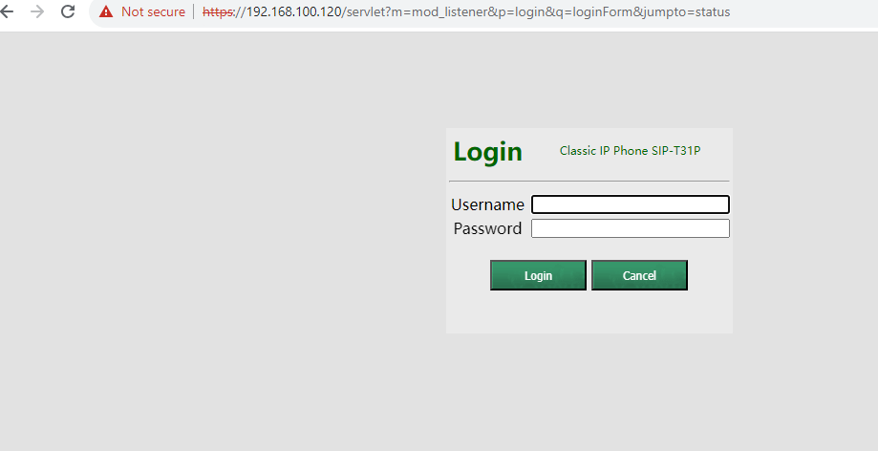
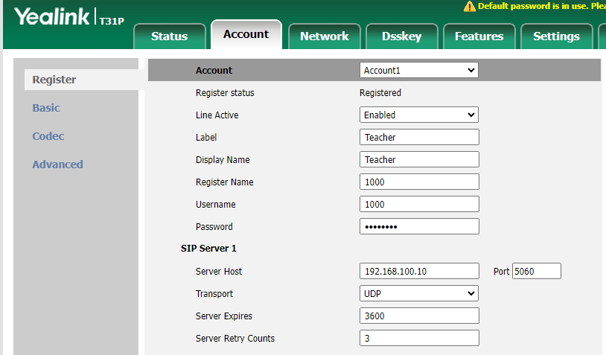
- Complete all information based on extension that you created
- Click Confirm

